End Semester Project Report on
Spinning Roulette Wheel Using Decade Counter CD4017 and NE555 Timer in TINA Software
Submitted for the partial fulfilment of the subject
Digital Circuits Workshop
(EET1708)

Group Members
Student Name: Ankush kumar (Regd. No.25E11B12)
Student Name: Amit mahabhoi (Regd. No.25E113A07)
Student Name: Shani kumar(Regd. No.25E111A81)

B. Tech. 2nd Semester (Section– 25E1U2 )



DEPT. OF ELECTRONICS & COMMUNICATION ENGINEERING
Institute of Technical Education and Research
SIKSHA ‘O’ ANUSANDHAN
DEEMED TO BE UNIVERSITY
Bhubaneswar, Odisha, India.
(2026)

Abstract
This project presents the design and simulation of an Electronic Roulette Wheel using digital electronic components in TINA software. The main objective of the project is to simulate the operation of a roulette wheel by generating a rotating sequence of LED’s and selecting a final output position electronically. The project demonstrates the practical application of timer circuits, decade counters, and LED display systems in digital electronics.
The proposed system uses a NE555 timer IC configured as an astable multivibrator to generate continuous clock pulses. These pulses are applied to a CD4017 decade counter, which sequentially activates its output pins. Each output is connected to an LED arranged in a circular pattern representing the positions of a roulette wheel. As the clock pulses are received, the LED’s glow one after another, creating the visual effect of a spinning roulette wheel. The speed of rotation depends on the frequency of the clock signal generated by the timer circuit. When the clock pulses are stopped, the counter halts at its current state and the corresponding LED remains illuminated, indicating the final selected position on the roulette wheel.
The complete circuit is implemented and simulated using TINA software to analyze the operation of the timer, decade counter, and LED display arrangement. The simulation verifies the correct functioning of the circuit and demonstrates the principles of sequential logic and electronic counting systems. The proposed system is simple, reliable, economical, and easy to implement. It can be used as an educational project for learning digital electronics, timer applications, counter circuits, and LED-based display systems. The project also helps in understanding pulse generation, output sequencing, and counter-based control techniques. Since the entire operation is performed electronically, the system requires minimal maintenance and provides stable performance. The proposed design can be further extended for use in electronic gaming and display-based applications.
Keywords:
NE555 Timer, CD4017 Counter, LED Sequencing, Roulette Wheel, TINA Software, Astable Multivibrator, RC Network, Sequential Logic.
Contents

Abstract 2
ANTICIPATION OF A SPINNING ROULETTE WHEEL 2
Objectives:…………………………………………………………………………………………..2
Working Principle : 3
Chapter 1: Introduction 8
1.1 Introduction…………………………………………………………………………………….8
Importance of Digital Systems 9
Applications in Modern Electronics 10
1.2 Need for Simulation…………………………………………………………………………..10
Advantages of Simulation before Hardware Implementation 10
Cost Reduction 11
Error Detection and Testing 11
1.3 Introduction to TINA Software………………………………………………………………11
Features of TINA Software 12
Digital Simulation Capabilities 12
Advantages over Manual Testing 12
1.4 Objectives of the Project……………………………………………………………………….13
Specific Objectives 13
1.5 Scope of the Project……………………………………………………………………………13
Educational Applications 14
Logic Design Verification 14
Research and Testing Purposes 14
Chapter 2: Literature Review 15
2.1 Overview of Digital Logic…………………………………………………………………….15
2.2 Previous Work………………………………………………………………………………….17
Existing Simulation Methods 17
Software Tools Used in Digital Electronics 18
2.3 Comparative Study……………………………………………………………………………18
TINA…… 19
Multisim…………………………………………………………………………………………..19
Proteus ………………………………………………………………………………………….19
Logisim……………… 19
Selection of TINA Software 19
Chapter 3: Software and Tools Used 21
3.1 Introduction to TINA………………………………………………………………………….21
Installation Process 21
Interface Overview 21
Menu Bar 22
Toolbar……………… 22
Component Library 22
Workspace Area 23
Virtual Instruments 23
3.2 Components Used…………………………………………………………………………….23
3.2.1. NE555 Timer IC 23
3.2.2. CD4017 Decade Counter IC 24
3.2.3. Transistor (NPN – BC556) 24
3.2.4. LEDs 25
3.2.5. Resistors and Capacitors 25
3.3 System Requirements………………………………………………………………………….26
RAM ………………………………………………………………………………………….27
Processor ………………………………………………………………………………………….27
Operating System 27
Additional Requirements 27
Chapter 4: Circuit Design and Methodology 28
4.1 Block Diagram…………………………………………………………………………………28
4.1.1. Block Description……………………………………………………………………………28
a. Touch Contact Switch 28
b. RC Network Block 28
c. BC557 Transistor Block 28
d. NE555 Timer Block 29
e. CD4017 Counter Block 29
f. LED Roulette Wheel Block 29
4.2 Algorithm / Flowchart………………………………………………………………………..29
Algorithm 29
4.3 Design Procedure……………………………………………………………………………..31
Step 1: Problem Identification 31
Step 2: Component Selection 31
Step 3: Timing Circuit Design 32
Step 4: Circuit Implementation 32
Step 5: Simulation and Testing 32
Expected Results 33
4.4 Circuit Diagrams………………………………………………………………………………33
a. Power & Charging Section……………………………………………………………………..34
Functions: 34
Components Used: 34
b. Astable Multivibrator………………………………………………………………………….34
Functions: 34
Components Used: 34
c. Decade Counter Section………………………………………………………………………..35
Functions: 35
Components Used: 35
d. LED Display…………………………………………………………………………………….35
Functions: 35
LED Outputs: 35
TINA Software Implementation Note 35
5.1 Simulation Setup………………………………………………………………………………36
Input Conditions 36
Components Used in Timing Section 37
Measurement Tools Used in TINA 37
5.2 LED Output Observation…………………………………………………………………….37
Observation of LED Operation 37
Sequential LED Operation 38
5.3 Truth Table Verification………………………………………………………………………38
Observation 38
5.4 Performance Analysis………………………………………………………………………….39
Accuracy 39
Response Time 39
Error Analysis 39
Solution to Errors 39
Chapter 6: Applications 40
6.1 Electronic Gaming Systems 40
Relation to Project: 40
Applications: 40
6.2 LED Chaser and Display Systems 40
Relation to Project: 40
Applications: 41
6.3 Digital Timing Circuits 41
Relation to Project: 41
Applications: 41
6.4 Sequential Logic Systems 41
Relation to Project: 41
Applications: 42
6.5 Educational and Laboratory Applications 42
Relation to Project: 42
Applications: 42
6.6 Entertainment Lighting Systems 42
Relation to Project: 42
Applications: 43
6.7 Prototype Development and Testing 43
Relation to Project: 43
Applications: 43
Chapter 7: Advantages and Limitations 44
7.1 Advantages………………………………………………………………………………………44
1. Simple Circuit Design 44
2. Low Cost Implementation 44
3. Easy Simulation and Testing 44
4. Attractive Visual Effect 44
5. Low Power Consumption 44
6. Educational Value 45
7. Reliable Sequential Operation 45
7.2 Limitations……………………………………………………………………………………..45
1. Limited Output Range 45
2. RC Timing Dependency 45
3. Simulation Differs from Practical Hardware 45
4. No True Random Generation 45
5. Limited Advanced Features 46
6. Component Tolerance Effects 46
Chapter 8: Conclusion and Future Scope 47
Conclusion 47
Summary of Work Completed 47
Results Obtained 47
Future Scope 48
References 49
Appendix 50
This appendix contains brief datasheet information and key specifications of the main components used in the Spinning Roulette Wheel Using Decade Counter CD4017 and NE555 Timer project. 50
A.1 NE555 Timer IC Datasheet Summary 50
Key Features: 50
Pin Configuration: 50
Operating Mode Used: 50
Applications: 50
A.2 CD4017 Decade Counter IC Datasheet Summary 50
Key Features: 51
Pin Configuration: 51
Operation: 51
Applications: 51
A.3 PNP Transistor (BC556) Datasheet Summary 51
Key Features: 51
Operation: 51
Applications: 52
A.4 LEDs (Light Emitting Diodes) 52
Key Features: 52
Function in Project: 52
Applications: 52
A.5 Resistors 52
Key Features: 52
Function in Project: 53
A.6 Capacitors 53
Key Features: 53
Function in Project: 53

Chapter 1: Introduction

Introduction
A roulette wheel is a circular rotating system commonly used in gaming and entertainment applications to generate random outputs. In electronics, the same spinning effect can be created using sequential LED circuits and timing devices. This project, “Spinning Roulette Wheel Using Decade Counter CD4017 and NE555 Timer in TINA Software,” is designed to simulate the working of a real roulette wheel using digital electronic components. The circuit uses LEDs arranged in a circular pattern where the LEDs glow one after another to create a rotating visual effect similar to a real roulette wheel.
The complete circuit is divided into four main sections: Power & Charging Section, Astable Multivibrator / Clock Generator Section, Decade Counter Section, and LED Display / Roulette Output Section. In the power and charging section, the capacitor charges when the SPIN switch is pressed. This charging action controls the BC556 transistor and starts the timer circuit operation. The NE555 Timer IC works as an astable multivibrator and continuously generates clock pulses. These pulses act as the input signal for the CD4017 decade counter.
The CD4017 decade counter receives the clock pulses from the NE555 timer and activates its outputs sequentially from Q0 to Q9. Each output is connected to one LED arranged in circular format. Due to sequential switching, the LEDs glow one-by-one in circular order, producing the spinning roulette wheel effect. Initially, the timer generates high-frequency pulses, causing rapid LED rotation. After releasing the SPIN switch, the capacitor slowly discharges through the RC timing network, reducing the pulse frequency gradually. As a result, the LED rotation slows down step-by-step until finally one LED remains ON as the final roulette output.
The entire circuit is designed and simulated using TINA Software, which is widely used for analysing analog and digital electronic circuits. TINA helps in observing pulse generation, timing behaviour, sequential counter operation, and LED sequencing without physically building the hardware circuit. This project demonstrates important concepts of digital electronics such as timers, counters, oscillators, RC timing circuits, transistor switching, capacitor charging and discharging, and sequential LED control systems. The project is highly useful for educational purposes, digital electronics laboratories, gaming electronics, and decorative LED display applications.

Importance of Digital Systems

- High speed operation
- Better accuracy and reliability
- Low power consumption
- Easy implementation and maintenance
- Improved noise immunity
- Compact circuit design
- Suitable for automation and gaming systems

Applications in Modern Electronics
Digital electronic systems are widely used in:
- LED display systems
- Gaming electronics
- Digital clocks
- Traffic light controllers
- Embedded systems
- Sequential control systems
- Entertainment lighting systems
The proposed roulette wheel project is an example of a simple and effective digital electronics application using timer and counter ICs.

Need for Simulation
Before implementing any electronic circuit in practical hardware form, simulation is an important step in the design process. Simulation allows designers to test, analyse, and verify circuit operation without physically building the hardware.
In digital electronics, simulation software is commonly used to analyse timing behaviour, logic operation, pulse generation, and output response. Simulation reduces design complexity and helps identify circuit errors before hardware implementation.
In this project, the complete spinning roulette wheel circuit is simulated using TINA Software. The simulation helps in verifying:
- NE555 Timer astable operation
- Clock pulse generation
- Sequential LED activation
- CD4017 counter operation
- Deceleration effect using RC network

Advantages of Simulation before Hardware Implementation

- Easy testing and modification of circuits
- Faster circuit analysis
- Safe operation without hardware damage
- Verification of output operation
- Better understanding of circuit behaviour
- Time-saving design process

Cost Reduction
Simulation reduces:

- Component wastage
- Hardware development cost
- Maintenance expenses
- Testing equipment requirements

Error Detection and Testing

Simulation helps to:
- Detect wiring errors
- Identify incorrect component values
- Verify LED sequencing operation
- Analyse timing problems
- Improve system reliability before practical implementation
Thus, simulation plays an important role in developing reliable and efficient digital electronic systems.

Introduction to TINA Software
TINA (Toolkit for Interactive Network Analysis) is an advanced electronic circuit simulation software used for designing, testing, and analysing analog, digital, and mixed electronic circuits. It provides a graphical environment where users can create electronic circuit diagrams using virtual components and analyse their behaviour without physically building the hardware.
TINA Software is widely used in educational institutions, laboratories, and research organizations for learning and developing electronic systems. The software supports a large number of electronic components such as logic gates, timers, counters, transistors, LEDs, resistors, capacitors, relays, operational amplifiers, and virtual measuring instruments.
In this project, TINA Software is used to design and simulate the “Spinning Roulette Wheel Using Decade Counter CD4017 and NE555 Timer.” The software helps in analysing pulse generation, LED sequencing operation, timing behaviour, counter output transitions, and gradual deceleration effects produced by the RC network.

Features of TINA Software
- Easy graphical circuit design
- Large electronic component library
- Analog and digital circuit simulation
- Real-time waveform analysis
- Virtual measuring instruments
- Error checking and debugging
- User-friendly interface
- Fast simulation process

Digital Simulation Capabilities
TINA supports:
- Logic gate simulation
- Sequential circuit analysis
- Timing diagram analysis
- Counter and flip-flop simulation
- Pulse and clock generation
- LED sequencing verification
- Output waveform observation

Advantages over Manual Testing
- No physical hardware required
- Faster testing process
- Safer operation
- Easy troubleshooting
- Accurate waveform analysis
- Easy modification of component values
- Better understanding of circuit operation
Therefore, TINA Software is highly suitable for educational projects, digital electronics learning, research work, and circuit development purposes.

Objectives of the Project
To design and simulate a Spinning Roulette Wheel Using Decade Counter CD4017 and NE555 Timer in TINA Software with sequential LED rotation and gradual slowdown effect.

Specific Objectives
- To use ten LEDs arranged in circular roulette wheel format.
- To generate clock pulses using NE555 Timer IC in astable mode.
- To perform sequential LED operation using CD4017 decade counter.
- To create a slowdown function in which LEDs initially blink rapidly after pressing the switch.
- To implement capacitor-based RC timing control for gradual reduction in LED rotation speed.
- To ensure that the LEDs gradually decrease in speed and finally stop at any one LED position.
- To display the final output using the LED that remains ON at the end of operation.
- To simulate the complete circuit using TINA Software.
- To analyse pulse generation, counter sequencing, and LED rotation behaviour.
To understand the practical application of digital electronics, timers, counters, and sequential logic circuits.

Scope of the Project
The scope of this project includes the design, simulation, testing, and analysis of a Spinning Roulette Wheel Using Decade Counter CD4017 and NE555 Timer using digital electronic components in TINA Software.
The project demonstrates the practical application of:
- NE555 Timer in astable mode
- CD4017 decade counter operation
- Sequential LED control systems
- RC timing and slowdown circuits
- Digital logic and timing circuits
- LED roulette wheel simulation
The system is designed to generate a realistic spinning roulette wheel effect in which LEDs rotate rapidly at first and gradually slow down before stopping at a random LED position.

Educational Applications
- Learning timer and counter circuits
- Understanding sequential logic systems
- Studying LED sequencing operations
- Practical learning using TINA simulation software
- Understanding capacitor charging and discharging action

Logic Design Verification
- Verification of clock pulse generation
- Sequential counter operation analysis
- LED output sequencing verification
- Timing behaviour observation
- Speed variation analysis using RC network

Research and Testing Purposes
- Electronic gaming systems
- LED display systems
- Digital timing applications
- Entertainment lighting circuits
- Prototype testing before hardware implementation
The project provides a simple, low-cost, and reliable method for understanding digital electronics concepts and sequential LED control systems.

Chapter 2: Literature Review

2.1 Overview of Digital Logic
The Roulette Wheel Simulation using LED Sequencing is a digital electronics project designed to simulate the working of a real roulette wheel through sequential LED rotation. The system uses an NE555 Timer IC operating in astable mode and a CD4017 decade counter to generate a rotating LED pattern that starts at high speed and gradually slows down before stopping randomly on one LED.The project demonstrates the practical implementation of timers, counters, sequential logic circuits, RC timing networks, and LED control systems. Ten LEDs are arranged in a circular pattern representing roulette positions numbered from 1 to 10. These LEDs glow one after another in sequence, creating the visual effect of a spinning roulette wheel.The NE555 Timer acts as the clock pulse generator. In astable mode, it continuously produces square wave pulses whose frequency depends on an RC timing network made of resistors and capacitors.
$$\text{f}\text{=}\frac{\text{1.44}}{\text{(}{\text{R}}_{\text{1}}\text{+2}{\text{R}}_{\text{2}}\text{)}\text{C}}$$
These clock pulses are supplied to the CD4017 decade counter, which advances its outputs sequentially from Q0 to Q9. Each output drives one LED, causing the LEDs to turn ON one at a time in circular order. After the last LED, the sequence repeats from the beginning, producing a continuous rotating effect.To create a realistic roulette motion, an RC slowdown circuit and a BC557 PNP transistor are incorporated. When the touch switch or trigger is pressed, the capacitor charges quickly and allows the timer to operate at high frequency, making the LEDs rotate rapidly. Once the trigger is released, the capacitor discharges slowly, gradually reducing the oscillation frequency of the timer. As a result, the LED rotation slows down step-by-step until the oscillation completely stops, leaving one LED glowing as the final random output.The complete circuit is designed and tested using TINA, which provides a virtual environment for analysing pulse generation, counter sequencing, timing behaviour, and LED operation before hardware implementation. Simulation helps verify the correctness of the circuit, detect errors, reduce component wastage, and improve system reliability.
This project is highly useful for understanding the fundamentals of digital electronics and sequential logic systems. It demonstrates concepts such as:
- Astable multivibrator operation
- Clock pulse generation
- Decade counter functioning
- LED sequencing
- Capacitor charging and discharging
- Timing control using RC networks
- Speed variation and deceleration effects
The roulette wheel simulation is a low-cost, compact, and educational electronic system that can be applied in gaming electronics, LED display systems, entertainment lighting, digital timing circuits, and learning laboratories. It also serves as an effective beginner-level project for students studying timers, counters, and digital control circuits.

2.2 Previous Work
Recent work in automatic lighting and sequencer circuits often builds on classic timer/counter ICs. For example, the NE555 timer IC is a stable, widely-used oscillator that produces precise timing pulses. These pulses can drive a CD4017 decade counter, which provides 10 decoded outputs that go HIGH one after another with each clock cycle. In practice, hobbyist “electronic dice” or LED-roulette projects commonly use a 555-plus-4017 circuit to sequentially light LED’s. More advanced systems incorporate sensors and micro-controllers – for instance, a PIR motion sensor coupled with an MCU can automatically switch room lights on/off based on movement. Nonetheless, simple digital timer/counter solutions remain popular for automated lighting because they are low-cost, easy to build, and reliable.
Sources: Electronics tutorials and data sheets describing the NE555 and CD4017 functions, and a study on a motion-sensor automatic light system

Existing Simulation Methods
Before implementing hardware circuits, simulation techniques are used to test and analyse system performance. Simulation helps designers verify logic operations, timing behaviour, and output responses without physically constructing the circuit.
Common simulation methods include:
- Analog simulation
- Digital simulation
- Mixed-mode simulation
- Timing analysis
- Waveform analysis
Simulation provides:
- Faster testing
- Error detection
- Reduced hardware cost
- Easy circuit modification
In this project, simulation is used to analyse:
- Monostable pulse generation
- Counter output operation
- Relay switching process
- Automatic light control

Software Tools Used in Digital Electronics
Various electronic simulation software tools are available for digital circuit design and testing. These software tools provide graphical interfaces and component libraries for creating and simulating electronic circuits.
Commonly used software includes:
- TINA
- Multisim
- Proteus
- Logisim
- LTspice
- MATLAB Simulink
These software tools support:
- Logic gate simulation
- Counter and timer analysis
- Waveform observation
- PCB design
- Virtual testing
Among these, TINA Software is selected in this project because of its simple interface, digital simulation capability, and easy waveform analysis.

2.3 Comparative Study
Different simulation software tools are available for digital electronics design and analysis. Each software has different features, advantages, and limitations. A comparative study of TINA, Multisim, Proteus, and Logisim is given below.
Feature | Tina | Multism | proteus | Logisim
Developer | Design soft | Natiional instruments | Labcenter Electronics | Open Source
Simulation Type | Analog & Digital | Analog & Digital | Embedded & Digital | Digital Only
User Interface | Simple | Proffesional | Advanced | Very simple
Logic simulation | Yes | Yes | Yes | Yes
Led and Counter Simulation | Good | Excellent | Good | Limited
Transistor Circuit Support | Yes | Yes | Yes | Yes
Timing Analysis | Good | Excellent | Good | Limited
PCB Design Support | No | Limited | yes | No
Educational Use | High | High | Moderate | High
Cost | Moderate | Expensive | Moderate | Free
Suitability for Roulette Wheel Project | Good | Very good | Excellent | Basic only

TINA
TINA is widely used for educational and industrial electronic circuit simulation. It supports analog, digital, and mixed-mode simulations with virtual instruments and waveform analysis. It is suitable for timer, counter, and logic circuit simulation.

Multisim
Multisim provides advanced simulation features and accurate circuit analysis tools. It is mainly used for professional electronic design and educational purposes. It supports large circuit simulation and PCB integration.

Proteus
Proteus is popular for embedded system simulation and microcontroller-based projects. It supports real-time microcontroller programming and hardware interfacing along with digital simulation.

Logisim
Logisim is simple open-source software mainly used for learning digital logic design. It supports basic logic gates, counters, and combinational circuit simulation but lacks advanced analog simulation features.

Selection of TINA Software
- TINA Software is selected for this project because:
- It provides easy digital circuit simulation.
- It supports timer and counter IC simulation.
- It has a simple graphical interface.
- It allows waveform observation and testing.
- It is suitable for educational projects and automation circuit analysis.
Therefore, TINA Software is an effective platform for designing and simulating the automatic bathroom light controller system.

Chapter 3: Software and Tools Used

3.1 Introduction to TINA
TINA (Toolkit for Interactive Network Analysis) is an electronic circuit simulation software used for designing, testing, and analysing analog, digital, and mixed electronic circuits. It provides a graphical environment where users can create electronic circuits using virtual components and analyse their operation without physical hardware implementation.
TINA Software is widely used in educational institutions, laboratories, and research organizations for learning and developing electronic systems. The software supports various electronic components such as logic gates, timers, counters, flip-flops, relays, transistors, operational amplifiers, and microcontrollers.
In this project, TINA Software is used to design and simulate the Spinning Roulette Wheel circuit. The software helps in observing pulse generation, LED sequencing operation, counter output transitions, and timing behaviour

Installation Process
The installation of TINA Software is simple and user-friendly. The basic installation steps are given below:
- Download the TINA setup file from the official website or installation source.
- Run the setup file by double-clicking the installer.
- Accept the software license agreement.
- Select the installation directory.
- Choose required program features and components.
- Click the install button to begin installation.
- Wait for the installation process to complete.
- Launch TINA Software after successful installation.
After installation, the software is ready for circuit design and simulation.

Interface Overview
The TINA Software interface consists of different sections used for circuit creation and simulation.

Main Parts of the Interface
- Menu Bar
- Toolbar
- Component Library
- Workspace Area
- Simulation Controls
- Virtual Instruments Panel

Menu Bar
The menu bar contains options such as:
- File
- Edit
- View
- Analysis
- Tools
- Help
These options are used for creating, saving, editing, and simulating circuits.

Toolbar
The toolbar provides quick access to commonly used functions such as:
- Open
- Save
- Zoom
- Wire connection
- Simulation start/stop

Component Library
The component library contains electronic components including:
- NE555 Timer IC
- CD4017 Counter IC
- Transistors
- Resistors
- Capacitors
- LEDs
- Switches
- Power supplies

Workspace Area
The workspace area is used to place components and design the circuit diagram.

Virtual Instruments
TINA provides virtual instruments such as:
- Oscilloscope
- Voltmeter
- Ammeter
- Logic Analyser
- Signal Generator
These instruments help in analysing circuit performance and output waveforms.

3.2 Components Used

3.2.1. NE555 Timer IC
The NE555 Timer is a highly stable integrated circuit used for generating accurate time delays and oscillations. In this project, it is configured in astable mode to generate continuous clock pulses for LED sequencing.
Key Features:
- Operates in astable modes
- Wide supply voltage range (4.5V to 15V)
- High timing accuracy
- Simple external components required
Working in this Project:
- Generates clock pulses
- Controls LED rotation speed
- Provides timing signals to CD4017 counter
Applications:
- Timing circuits
- Pulse generation
- Oscillators
- LED flasher circuits

3.2.2. CD4017 Decade Counter IC
The CD4017 is a 5-stage Johnson decade counter with 10 decoded outputs. It is widely used in sequential switching applications.
Key Features:
- 10 decoded outputs (Q0–Q9)
- Works with clock pulses
- Low power CMOS IC
- Sequential output operation
Working in this Project:
- Receives clock pulses from NE555 Timer
- Activates LEDs sequentially
- Produces roulette wheel effect
Applications:
- LED chaser circuits
- Counters
- Sequencing circuits
- Display systems

3.2.3. Transistor (PNP – BC556)
The BC557 is a PNP transistor used for switching and control applications.
Key Features:
- Low power transistor
- Fast switching operation
- Small size and low cost
Working in this Project:
- Controls timing operation
- Helps in slowdown effect
- Controls current flow in the circuit
Applications:
- Switching circuits
- Timing control systems
- Signal amplification

3.2.4. LED’s
LED’s (Light Emitting Diodes) are semiconductor devices that emit light when current passes through them.

Key Features:
- Low power consumption
- Fast response time
- Long operating life
Working in this Project:

- Arranged in circular roulette pattern
- Glow sequentially
- Produce spinning visual effect
Applications:
- Display systems
- Decorative lighting
- Indicator systems

3.2.5. Resistors and Capacitors

Resistors
Resistors are passive components used to limit current flow and provide proper biasing conditions.
Functions in this Project:
- Current limiting
- Timing control
- Biasing operation
Applications:
- Current limiting
- Voltage division
- Biasing circuits
- Timing control

Capacitors
Capacitors store and release electrical energy and are widely used in timing circuits.
Functions in this Project:
- RC timing operation
- Charging and discharging action
- Speed reduction control
- Frequency variation
Applications:
- Timing circuits
- Oscillator circuits
- Filtering applications
- Energy storage
- Pulse generation circuits

3.3 System Requirements
To install and run TINA Software properly, the computer system should meet minimum hardware and software requirements.

RAM
- Minimum: 2 GB RAM
- Recommended: 4 GB or higher
Adequate RAM is required for smooth simulation and waveform analysis.

Processor
- Minimum: Intel Core i3 or equivalent
- Recommended: Intel Core i5/i7 or higher
A faster processor improves simulation speed and circuit analysis performance.

Operating System
TINA Software supports:
- Windows 7
- Windows 8
- Windows 10
- Windows 11
64-bit operating systems are preferred for better performance.

Additional Requirements
- Minimum 500 MB free disk space
- Mouse and keyboard
- Display resolution of 1024 × 768 or higher
These system requirements ensure efficient circuit design and smooth simulation performance in TINA Software.

Chapter 4: Circuit Design and Methodology

4.1 Block Diagram
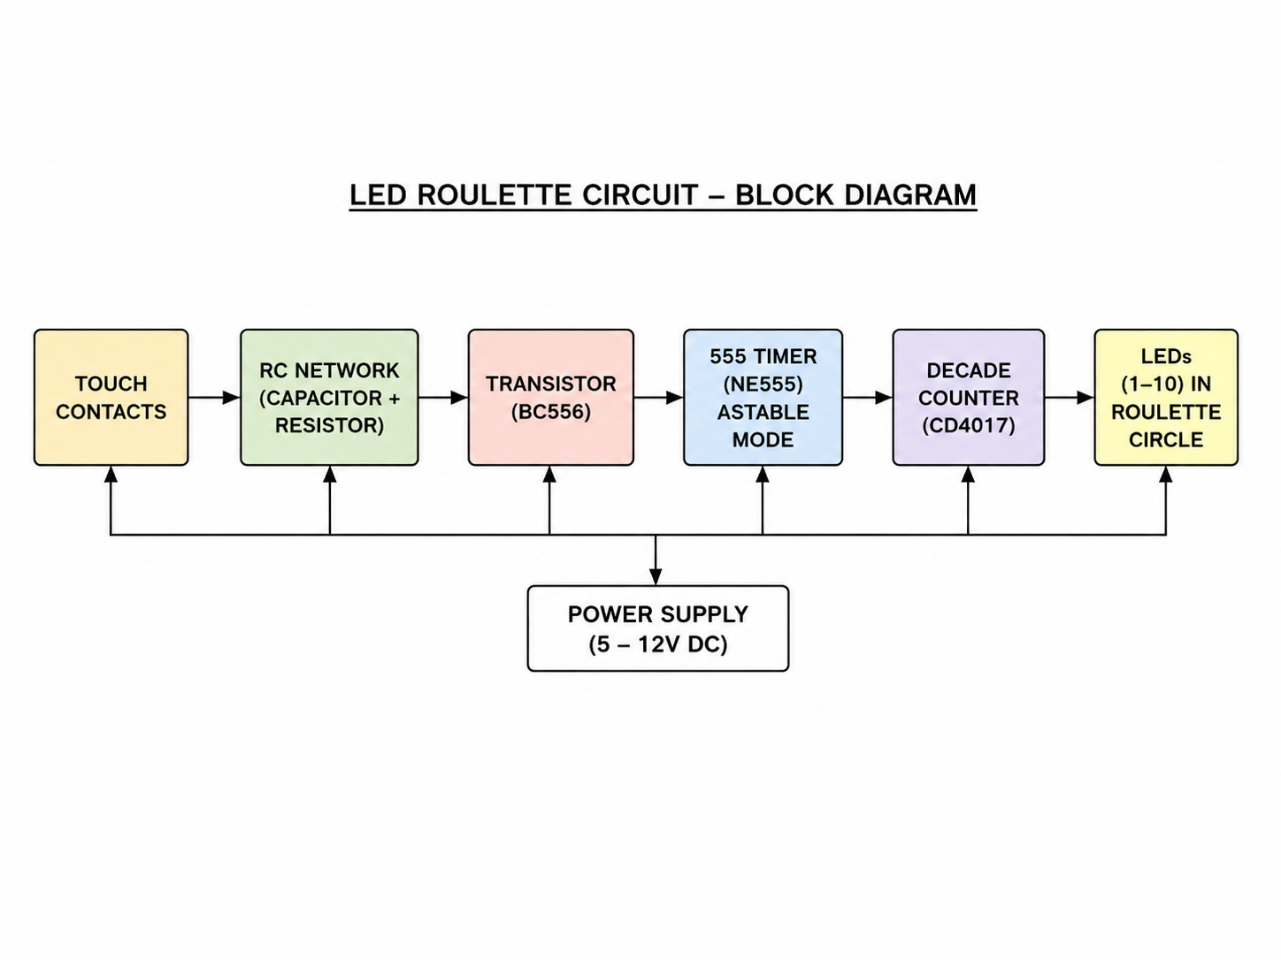
Figure 4.1: Block Diagram of Spinning Roulette Wheel

4.1.1. Block Description

a. Touch Contact Switch
- Acts as the input trigger of the system
- Starts the spinning operation of LEDs
- Provides initial signal to the RC network

b. RC Network Block
- Consists of resistor and capacitor combination
- Controls charging and discharging operation
- Produces gradual slowdown effect
- Controls timing variation of LED rotation

c. BC556 Transistor Block
- Works as switching and control device
- Controls signal flow to the timer circuit
- Helps in speed variation operation
- Supports gradual stopping effect

d. NE555 Timer Block
- Operates in astable mode
- Generates continuous clock pulses
- Controls LED rotation speed
- Provides clock input to CD4017 counter

e. CD4017 Counter Block
- Works as decade counter
- Activates outputs sequentially
- Controls LED sequencing operation
- Produces roulette wheel effect

f. LED Roulette Wheel Block
- Consists of 10 LEDs arranged in circular form
- LEDs glow sequentially
- Creates spinning visual effect
- Final LED represents roulette output

4.2 Algorithm / Flowchart

Algorithm
- Start
- Supply power to circuit
- Charge capacitor
- Press SPIN switch
- Activate 555 timer
- Generate clock pulses
- Send pulses to CD4017
- Rotate LEDs sequentially
- Capacitor discharges slowly
- Rotation speed decreases
- One LED remains ON
- Display final output
- End
Flowchart:
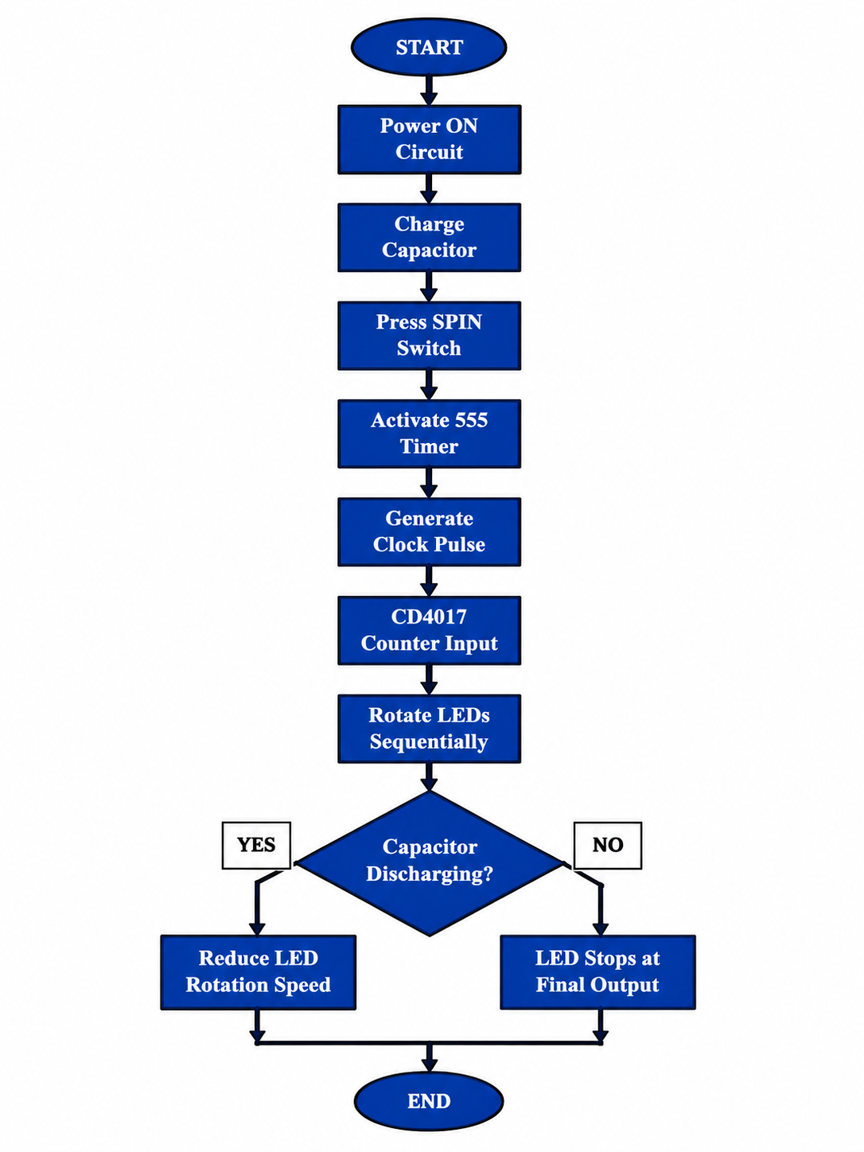

Figure 4.2: Flowchart of Spinning Roulette Wheel

4.3 Design Procedure
The design of the Spinning Roulette Wheel circuit is carried out systematically to ensure proper operation and accurate simulation using TINA Software.

Step 1: Problem Identification
The first step is to identify the project objective.
The system should:

- Rotate LEDs in roulette wheel pattern
- Initially rotate LEDs rapidly
- Gradually reduce rotation speed
- Finally stop at one LED position
- Produce random roulette output

Step 2: Component Selection
The following components are selected:
- NE555 Timer IC
- CD4017 Decade Counter
- BC556 Transistor
- Resistors
- Capacitors
- LEDs
- DC Power Supply
These components are selected because of:
- Simple circuit design
- Low cost
- Reliable operation
- Easy simulation capability

Step 3: Timing Circuit Design
- NE555 Timer is configured in astable mode
- RC network determines pulse frequency
- Capacitor charging/discharging controls slowdown operation
- Pulse frequency gradually decreases with time

Step 4: Circuit Implementation
The circuit is implemented in the following stages:

a) Input Stage
- Touch contacts used as trigger input
- Starts circuit operation

(b) Timing Stage
- RC network controls timing behaviour
- NE555 generates oscillation pulses

(c) Counter Stage
- CD4017 performs sequential output switching
- LEDs activate one-by-one

(d) Output Stage
- LEDs display roulette spinning effect
- Final LED remains ON as result

Step 5: Simulation and Testing
The circuit is designed and tested using TINA Software.

Testing Steps:
- Apply power supply
- Activate touch input
- Observe NE555 pulse generation
- Verify CD4017 output sequencing
- Check LED rotation operation
- Observe gradual slowdown effect
- Verify final LED output

Expected Results
- LEDs rotate rapidly at beginning
- Rotation speed gradually decreases
- One LED finally remains ON
- Roulette effect successfully achieved
Simulation confirms proper operation of the system.

4.4 Circuit Diagrams
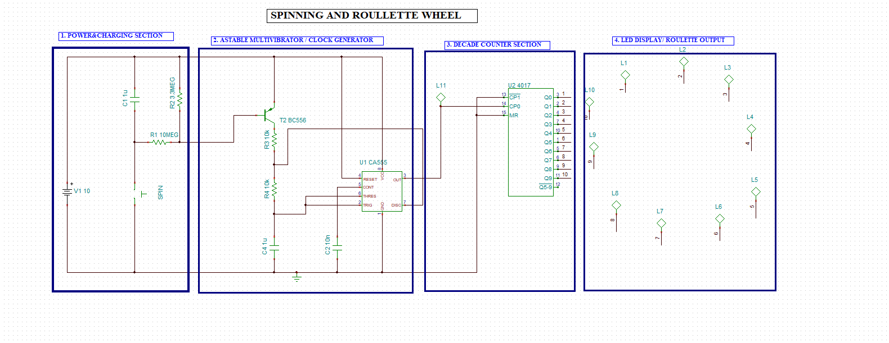
Figure 4.3: Implemented Circuit of Spinning Roulette Wheel

The complete circuit is divided into functional blocks:

a. Power & Charging Section
This section provides DC power supply to the circuit and controls capacitor charging and discharging operation.

Functions:
- Supplies power to the circuit
- Controls slowdown effect
- Performs RC timing operation

Components Used:
- DC Supply
- Resistors
- Capacitor
- Touch switch

b. Astable Multivibrator
The NE555 Timer operates in astable mode and generates continuous clock pulses.

Functions:
- Generates clock pulses
- Controls LED rotation speed
- Provides input pulses to CD4017

Components Used:
- NE555 Timer IC
- Resistors
- Capacitors
- Transistor

c. Decade Counter Section
The CD4017 counter receives pulses from the NE555 Timer and activates outputs sequentially.

Functions:
- Sequential counting operation
- LED sequencing control
- Roulette wheel operation

Components Used:
- CD4017 Decade Counter IC

d. LED Display
This section contains ten LEDs arranged in roulette wheel format.

Functions:
- Displays spinning effect
- Shows sequential LED output
- Displays final roulette result

LED Outputs:
- ONE to TEN LEDs
Initially LEDs rotate rapidly and gradually slow down until one LED remains ON.

TINA Software Implementation Note
In TINA Software:
- Components are selected from library
- Circuit is drawn using wire tool
- Power supply is applied
- Simulation is executed
Chapter 5: Simulation and Results

5.1 Simulation Setup
The complete Spinning Roulette Wheel Using Decade Counter CD4017 and NE555 Timer circuit is designed and simulated using TINA Software. The simulation verifies the operation of the power section, RC timing network, BC556 transistor switching, NE555 astable multi-vibrator, CD4017 decade counter, and LED roulette display section.

Input Conditions
The input to the system is provided using the SPIN switch.
- SPIN switch pressed → Starts roulette operation
- Capacitor charges through RC network
- BC556 transistor turns ON
- NE555 Timer starts generating pulses
- LEDs rotate rapidly in sequence
When the SPIN switch is released:
- Capacitor slowly discharges
- BC556 transistor gradually turns OFF
- NE555 pulse frequency decreases
- LED rotation slows down gradually
- Finally one LED remains ON as final roulette output
The SPIN switch is connected to the RC charging section and BC556 transistor control circuit.
Clock Pulse Settings
The clock pulses are generated by the NE555 Timer operating in astable mode.
- Continuous clock pulses generated by NE555
- Pulse frequency controlled by RC timing network
- High frequency causes fast LED rotation
- Frequency gradually decreases during capacitor discharge

Components Used in Timing Section
- R1 = 10 MΩ
- R2 = 3.3 MΩ
- R3 = 10 kΩ
- R4 = 10 kΩ
- C1 = 1 µF
- C2 = 10 nF
- C4 = 1 µF
- BC556 Transistor
- NE555 Timer IC
These components control the spinning speed and slowdown effect of the roulette wheel system.

Measurement Tools Used in TINA
The following virtual tools are used during simulation:
- LED indicators
- Logic probe
- Voltmeter
- Oscilloscope
These tools help in verifying:
- Clock pulse generation
- Sequential LED operation
- Counter output transitions
- Slowdown behaviour of the roulette wheel system

5.2 LED Output Observation
The simulation results show proper operation of the roulette wheel system.

Observation of LED Operation
- LEDs initially rotate rapidly in circular sequence
- NE555 Timer continuously generates clock pulses
- CD4017 counter activates LEDs one-by-one
- RC network gradually reduces pulse frequency
- LED rotation speed decreases slowly
- Finally one LED remains ON as roulette result

Sequential LED Operation
LED outputs operate in the following sequence:
LED1 → LED2 → LED3 → LED4 → LED5 → LED6 → LED7 → LED8 → LED9 → LED10
After LED10, the sequence repeats again from LED1.

5.3 Truth Table Verification
The simulation results are verified using expected output conditions.
Trigger Condition | Expected Result | Simulated Result | Status
Touch Activated | Fast LED Rotation | Fast Rotation Observed | Correct
Clock Pulses Applied | Sequential LED Operation | Sequential LEDs Observed | Correct
Capacitor Discharge | Slowdown Effect | Gradual Slowdown Observed | Correct
Final State | One LED Remains ON | One LED ON | Correct

Observation
- CD4017 counter operated correctly
- NE555 Timer generated stable pulses
- LED sequencing worked properly
- Slowdown effect successfully achieved
Thus, the simulation verifies correct operation of the complete roulette wheel system.

5.4 Performance Analysis
The performance of the system is analysed based on speed control, sequential operation, and output stability.

Accuracy
- Sequential LED operation achieved successfully
- Counter outputs activated correctly
- No incorrect LED switching observed
- Stable roulette operation obtained

Response Time
- NE555 Timer generated fast pulse response
- CD4017 counter reacted immediately to clock input
- LEDs responded quickly during sequencing operation

Error Analysis
Possible practical errors may include:
- Incorrect resistor or capacitor values
- Noise in timing circuit
- Loose circuit connections
- Improper power supply voltage

Solution to Errors
- Use correct RC component values
- Provide stable DC power supply
- Verify proper circuit wiring
- Use good quality components
The simulation results confirm successful implementation of the Spinning Roulette Wheel Using Decade Counter CD4017 and NE555 Timer project.

Chapter 6: Applications
The Spinning Roulette Wheel Using Decade Counter CD4017 and NE555 Timer demonstrates important concepts of digital electronics such as timing circuits, counters, sequential logic, RC timing networks, and LED control systems. These concepts are widely used in many practical electronic and industrial applications.

6.1 Electronic Gaming Systems
Electronic gaming systems use timers, counters, LEDs, and sequential logic circuits to create random visual effects and game outputs.

Relation to Project:
- The roulette wheel operates like an electronic game system
- LEDs rotate sequentially to create gaming effects
- Random stopping operation simulates roulette selection
- Timer and counter circuits control game behaviour

Applications:
- Electronic roulette systems
- LED gaming circuits
- Digital dice systems
- Arcade electronic games

6.2 LED Chaser and Display Systems
LED chaser circuits are widely used in decorative lighting and display applications where LEDs glow sequentially.

Relation to Project:
- CD4017 controls sequential LED operation
- NE555 Timer generates clock pulses for LED movement
- LEDs glow one after another in circular sequence

Applications:
- Decorative LED lighting
- Sequential advertising displays
- Festival lighting systems
- Animation display circuits

6.3 Digital Timing Circuits
Digital timing circuits use oscillators, counters, and RC networks to control timing operations in electronic systems.

Relation to Project:
- NE555 Timer works as astable oscillator
- RC network controls timing variation
- Pulse frequency determines rotation speed

Applications:
- Pulse generation circuits
- Oscillator systems
- Timer-based automation
- Delay generation circuits

6.4 Sequential Logic Systems
Sequential logic circuits are used in systems where outputs change according to clock pulses and previous states.

Relation to Project:
- CD4017 decade counter performs sequential output switching
- LEDs activate according to counter sequence
- Clock pulses control output transitions

Applications:
- Counter circuits
- Digital sequencing systems
- State machine circuits
- Event control systems

6.5 Educational and Laboratory Applications
The project is highly useful for learning digital electronics concepts and practical circuit simulation techniques.

Relation to Project:
- Demonstrates timer and counter operation
- Shows practical RC timing control
- Helps understand LED sequencing systems
- Provides hands-on learning using TINA Software

Applications:
- Digital electronics laboratories
- Engineering mini-projects
- Educational demonstrations
- Sequential logic experiments

6.6 Entertainment Lighting Systems
Entertainment systems use sequential LED lighting effects to create attractive visual patterns.

Relation to Project:
- LEDs rotate in circular roulette pattern
- Speed variation creates realistic visual effect
- Sequential lighting produces animation effect

Applications:
- Stage lighting systems
- Decorative lighting controllers
- LED animation systems
- Event lighting displays

6.7 Prototype Development and Testing
Simulation-based circuit development helps designers test systems before practical hardware implementation.

Relation to Project:
- TINA Software verifies circuit operation
- Helps analyse timing and sequencing behaviour
- Reduces hardware testing errors
- Improves system reliability

Applications:
- Circuit prototype testing
- Digital system verification
- Educational simulation projects
- Research and development work
The project successfully demonstrates the practical applications of timers, counters, sequential logic systems, RC timing circuits, and LED display technologies in modern digital electronics.

Chapter 7: Advantages and Limitations

7.1 Advantages
The Spinning Roulette Wheel Using Decade Counter CD4017 and NE555 Timer provides several advantages in digital electronics learning and sequential LED control applications.

1. Simple Circuit Design
- Uses easily available electronic components
- Easy to design and understand
- Suitable for beginner-level electronics projects

2. Low Cost Implementation
- Requires low-cost components
- No expensive devices required
- Economical for educational projects

3. Easy Simulation and Testing
- Can be easily simulated using TINA Software
- Circuit operation can be verified before hardware implementation
- Reduces hardware testing errors

4. Attractive Visual Effect
- LEDs create realistic spinning roulette effect
- Gradual slowdown increases visual appearance
- Provides entertainment and display applications

5. Low Power Consumption
- LEDs consume low power
- CMOS CD4017 counter requires very small current
- Suitable for battery-operated systems

6. Educational Value
- Demonstrates NE555 Timer operation
- Helps understand sequential logic systems
- Explains counter and RC timing concepts
- Useful for digital electronics laboratories

7. Reliable Sequential Operation
- CD4017 provides accurate sequential LED activation
- Stable clock pulses generated by NE555 Time

7.2 Limitations
Although the system provides many advantages, some limitations are also present.

1. Limited Output Range
- CD4017 provides only 10 decoded outputs
- Number of LEDs is limited without additional circuitry

2. RC Timing Dependency
- Speed control depends on resistor and capacitor values
- Incorrect RC values may affect slowdown operation

Simulation Differs from Practical Hardware
- Real hardware may contain noise and voltage variations
- Practical performance may slightly differ from simulation results

4. No True Random Generation
- Final LED output depends on timing conditions
- Randomness is not completely unpredictable

5. Limited Advanced Features
- No microcontroller or programmable control used
- Cannot store previous outputs or game statistics

6. Component Tolerance Effects
- Resistor and capacitor tolerances may affect timing accuracy
- Frequency variation may change slightly in practical circuits
Despite these limitations, the project successfully demonstrates the working principles of timers, counters, sequential logic systems, and LED sequencing circuits in digital electronics.

Chapter 8: Conclusion and Future Scope

Conclusion
The Spinning Roulette Wheel Using Decade Counter CD4017 and NE555 Timer was successfully designed and simulated using TINA Software. The project demonstrated the practical implementation of digital electronics concepts such as timer circuits, sequential logic systems, LED sequencing, and RC timing control. The NE555 Timer generated continuous clock pulses, which were applied to the CD4017 decade counter to activate LEDs sequentially in a circular pattern and create the spinning roulette wheel effect.
During operation, the LEDs initially rotated at high speed and then gradually slowed down due to the RC timing network and BC556 transistor control circuit. Finally, one LED remained ON as the final roulette output. The simulation results verified proper pulse generation, sequential LED operation, slowdown effect, and stable counter performance. The project also helped in understanding the practical applications of timers, counters, transistors, and LED control systems in digital electronics.

Summary of Work Completed
• Designed and simulated the complete roulette wheel circuit using TINA Software.
• Configured the NE555 Timer in astable mode for continuous clock pulse generation.
• Implemented the CD4017 decade counter for sequential LED operation.
• Arranged LEDs in circular format to create roulette wheel effect.
• Designed RC timing network for gradual slowdown operation.
• Used BC556 transistor for timing and switching control.
• Verified sequential LED rotation and final stopping effect through simulation.
• Analysed pulse generation, timing behaviour, and counter operation successfully.

Results Obtained
• Fast LED rotation was achieved successfully during initial operation.
• Sequential LED switching was observed correctly without errors.
• RC timing network produced smooth slowdown effect in LED rotation.
• One LED finally remained ON as the roulette output result.
• Stable clock pulses were generated by the NE555 Timer circuit.
• Correct sequential counting operation was achieved using CD4017 counter.
• Complete roulette wheel simulation operated successfully in TINA Software.

Future Scope
• The project can be implemented using microcontrollers such as Arduino for programmable control.
• FPGA and VLSI implementation can improve speed and system integration.
• IoT technology can be added for wireless monitoring and control.
• Sound effects and LCD displays can be integrated for better user interaction.
• Advanced random number generation techniques can improve output randomness.
• Practical PCB hardware implementation can be developed from the simulated design.
• The system can be used in decorative lighting and entertainment applications.

References
- M. Morris Mano, “Digital Design / Digital Logic and Computer Design”, Pearson Education.
(Standard textbook for understanding Boolean algebra, logic gates, counters, and sequential circuits used in this project.)
- TINA Design Suite User Manual, DesignSoft.
Available at: TINA Software Official Website
(Provides complete guidance for circuit design, simulation, and analysis using TINA software.)
- IEEE Research Papers on Digital Electronics and Simulation Techniques
(Used for understanding modern digital circuit design methods, simulation approaches, and automation systems.)
- Texas Instruments, NE555 Timer IC Datasheet
(Used for studying pin configuration, monostable operation, and timing characteristics.)
- Texas Instruments, CD4017 Decade Counter Datasheet
(Used for understanding counter operation, pin details, and MOD-2 configuration.)
- Electronics Tutorials and Educational Websites
(Used for learning basic digital logic concepts, relay driver circuits, and transistor switching operations.)
- Standard Digital Electronics Lab Manuals
(Used for practical understanding of logic gates, counters, and timing circuits in academic projects.)

Appendix

This appendix contains brief datasheet information and key specifications of the main components used in the Spinning Roulette Wheel Using Decade Counter CD4017 and NE555 Timer project.

A.1 NE555 Timer IC Datasheet Summary
The NE555 is a precision timer IC used for generating time delays, pulses, and oscillations. In this project, the NE555 Timer is used in astable mode to generate continuous clock pulses for LED sequencing.

Key Features:
Supply Voltage: 4.5V to 15V (typical up to 18V)
• High timing accuracy
• Adjustable duty cycle
• TTL compatible output

Pin Configuration:
- GND
- Trigger
- Output
- Reset
- Control Voltage
- Threshold
- Discharge
- VCC

Operating Mode Used:
Astable Mode (continuous pulse generator)

Applications:
Timing circuits
• Pulse generation
• Oscillators
• LED flasher circuits

A.2 CD4017 Decade Counter IC Datasheet Summary
The CD4017 is a CMOS Johnson decade counter with 10 decoded outputs.

Key Features:
- Supply Voltage: 3V to 15V
- 10 decoded outputs (Q0 to Q9)
- Low power CMOS technology
- High noise immunity

Pin Configuration:
- Clock Input (Pin 14)
- Reset (Pin 15)
- Enable (Pin 13)
- Outputs Q0–Q9
- VDD and GND

Operation:
- Advances one output HIGH for each clock pulse
- Produces roulette wheel sequencing effect
- Used for sequential LED operation

Applications:
- Counters
- LED sequencing
- Timing systems
- Digital control circuits

A.3 PNP Transistor (BC556) Datasheet Summary
The BC556 transistor is used as a switching and timing control device in the roulette wheel circuit.

Key Features:
- Maximum Collector Current: ~100 mA
- Voltage rating: up to 65V (approx.)
- Fast switching speed
- High current gain (β)

Operation:
- Base current controls collector-emitter conduction
- Works in:
  - Cut-off region (OFF state)
  - Saturation region (ON state)

Applications:
- Switching circuits
- Timing control system
- Signal amplification
- sequential control systems

A.4 LEDs (Light Emitting Diodes)
LED's are semiconductor devices that emit light when current passes through them.

Key Features:
• Low power consumption
• Fast response time
• Long operating life

Function in Project:
• Arranged in circular roulette pattern
• Glow sequentially
• Produce spinning visual effect

Applications:
• Display systems
• Decorative lighting
• Indicator systems

A.5 Resistors
Resistors are passive components used to control current flow.

Key Features:
- Measured in Ohms (Ω)
- Available in different power ratings (1/4W, 1/2W, etc.)

Function in Project:
- Timing control (555 Timer)
- Base current limiting (transistor)
- RC timing operation

A.6 Capacitors
Capacitors store and release electrical energy in electric fields.

Key Features:
- Measured in Farads (F)
- Common values: µF, nF, pF
- Polarized (electrolytic) and non-polarized types

Function in Project:
- Timing element in 555 Timer
- Charging and discharging operation
Slowdown effect generation
Frequency variation control

